



Annual Report 2022–23

**Disclaimer**

This publication may be of assistance to you, but the State of Victoria and its employees do not guarantee that the publication is without flaw of any kind or is wholly appropriate for your particular purposes and therefore disclaims all liability for any error, loss or other consequence which may arise from you relying on any information in this publication.

While every effort has been made to ensure the currency, accuracy or completeness of the content we endeavour to keep the content relevant and up to date and reserve the right to make changes as required. The Victorian Government, authors and presenters do not accept any liability to any person for the information (or the use of the information) which is provided or referred to in the report.

Authorised by the Victorian Government Department of Jobs, Skills, Industry and Regions

121 Exhibition St, Melbourne Victoria 3000

Telephone: 13 22 15

Prepared under section 10 of the *Local Jobs First Act 2003*

November 2023

© State of Victoria 2023

Unless indicated otherwise, this work is made available under the terms of the Creative Commons Attribution 3.0 Australia Licence. To view a copy of this licence, visit [Creative Commons](https://www.creativecommons.org/licenses/by/3.0/au/).

It is a condition of this Creative Commons Attribution 3.0 Licence that you must give credit to the original author who is the State of Victoria.

Contents

Minister for Jobs and Industry Foreword 3

Minister for Employment Foreword 5

1. About Local Jobs First 10

2. Implementation of Local Jobs First 12

2.1. Local Jobs First Commissioner 12

2.2. Message from the Local Jobs First Commissioner – Ms Moana Weir 12

2.3. Industry Capability Network Victoria 13

2.4. Department of Jobs, Skills, Industry and Regions 14

3. Local Jobs First Outcomes in 2022‑23 16

3.1. Strategic Projects 16

3.2. Commenced Projects 20

3.3. Completed Projects 21

3.4. Major Projects Skills Guarantee 21

3.5. Local Content 21

3.6. Grants 21

3.7. Exemptions 22

Local Jobs First Highlights 23

3.8. Strategic Project Records and Milestones 23

3.9. Additional Requirements set for Strategic Projects 23

3.10. Industry Impacts of Steel and FF&E Requirements 25

3.11. Local Jobs First Standard Projects 27

Appendix A: Completed Strategic Projects for 2022‑23 28

# Minister for Jobs and Industry Foreword

On behalf of the Victorian Government and together with the Minister for Employment, I am pleased to present the 2022‑23 Local Jobs First Annual Report.

Local Jobs First is Australia’s longest standing industry participation policy and creates more opportunities for small and medium sized businesses to work on public projects, while securing more local jobs and delivering economic benefits for Victorians across the state.

Through Local Jobs First, we’re using our purchasing power to ensure local companies can compete for both large and small government contracts by setting local content requirements on Strategic Projects.

From December 2014 until 30 June 2023, we’ve set local content requirements for 300 Strategic Projects, with a combined total value of more than $144.6 billion, supporting more than 50,000 jobs.

This includes $26 billion worth of projects in 2022‑23, which have committed to engaging local businesses and supporting local jobs, powering the Victorian economy.

Local Jobs First continues to support the next generation of our workforce, with more than 10,300 apprentices, trainees and cadets employed since the introduction of the Major Projects Skills Guarantee (MPSG) in 2016.

More than 15 million hours have been worked, with a further 6.4 million hours committed, creating vital work experience for young Victorians.

This financial year, the Local Jobs First Policy and guidelines were further updated and refreshed to strengthen policy outcomes and simplify application for agencies and industry.

This includes improved guidance and processes for the MPSG and a new MPSG Policy Statement to complement the Local Jobs First Policy.

It’s never been more important to support local businesses, as companies faced ongoing supply chain challenges and increased material costs.

We remain committed to sourcing local content where possible and ensuring that Victorian businesses have a full and fair opportunity to compete for government contracts.

Businesses are also supported through the Industry Capability Network’s extensive supply chain expertise, which has connected thousands of Victorian companies to government projects, while providing important data and insights about our industry capabilities.

We will continue to work with the Local Jobs First Commissioner, Ms Moana Weir on compliance and enforcement to ensure all agencies and contractors deliver on their obligations.

I commend the many Victorian Government agencies that have applied Local Jobs First to their projects, and thank local businesses, workers, apprentices, trainees and cadets who continue to help build our state through their work.

This important initiative has its 20th anniversary in October 2023 and as this report outlines, it has been a big year for the Local Jobs First Policy.

From level crossing removals to the Metro Tunnel and Wonthaggi Hospital, the strong Local Jobs First requirements that have been set on these projects are providing local businesses and workers with the opportunity to build Victoria’s future.

Through Local Jobs First, we’re investing in the success of our local industry and workforce.

**The Hon Natalie Hutchins MP**Minister for Jobs and Industry

# Minister for Employment Foreword

Together with the Minister for Jobs and Industry, we present to you on behalf of the Victorian Government the 2022-23 Local Jobs First Annual Report.

Local Jobs First is a key initiative of the Victorian Government, generating thousands of employment opportunities across the state and supporting workers to develop the skills they need for long, rewarding and successful careers.

The Local Jobs First policy also ensures that local businesses can compete for both large and small Victorian Government contracts across a variety of projects, from rail and roads to health and education.

In the 2022-23 financial year 365 projects commenced with local content requirements, supporting nearly 11,000 jobs and providing more than 24,300 opportunities for small to medium enterprises.

Additionally, Local Jobs First continued to invest in the next generation of talent through the Major Projects Skills Guarantee (MPSG) which has supported more than 10,300 apprentices, trainees and cadets on 400 projects since its introduction in 2016.

The MPSG requires all Victorian Government projects valued at $20 million or more to reserve labour hours for people starting out in their careers.

With more than 15 million hours worked since the MPSG was introduced, that’s countless opportunities for early career Victorians.

We’re proudly backing projects and employers that are making a real difference for local communities and workers.

Projects include the Frankston Health Redevelopment Project - kick-starting the careers of 68 apprentices, trainees and cadets by providing high-value work and skills development opportunities.

The North East Link Project is also giving young workers the valuable experience of working on a major project while completing an apprenticeship with an Aboriginal owned and operated business.

By supporting these ventures, we’re strengthening Victoria’s workforce and economy, equipping our industries with strong, skilled and determined workers.

Thank you to the local businesses and workers who have contributed to Local Jobs First projects, shaping the future of our state.

It’s exciting to see the ongoing benefits of these projects – and the jobs they’re creating right here in Victoria.

**Ms Vicki Ward MP**Minister for Employment

**From 2014 until 30 June 2023, the Local Jobs First Policy has been applied to**

* 300 strategic projects
* 179 Metro projects
* 64 Regional projects
* 57 Statewide projects

Worth $144.6 billion

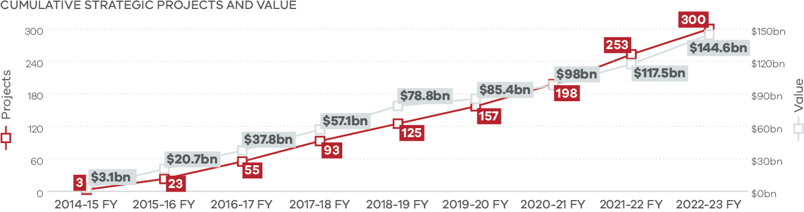

|  |  |  |
| --- | --- | --- |
|  | Projects | Value ($bn) |
| 2014-15 FY | 3 | 3.1 |
| 2015-16 FY | 23 | 20.7 |
| 2016-17 FY | 55 | 37.8 |
| 2017-18 FY | 93 | 57.1 |
| 2018-19 FY | 125 | 78.8 |
| 2019-20 FY | 157 | 85.4 |
| 2020-21 FY | 198 | 98 |
| 2021-22 FY | 253 | 117.5 |
| 2022-23 FY | 300 | 144.6 |

Ministerial requirements

* 88% average minimum local content

85 projects with a local steel requirement

Local Industry Development Plan commitments

* 79% average local content
* 95% average local steel content

50,399 jobs committed

A Strategic Project is a project with a budget of $50 million or more or that has been declared as a Strategic Project by the Minister for Jobs and Industry.

**Since 2015, the Local Jobs First Policy has been applied to**

* 2,536 Standard projects
* 1,030 Metro projects
* 1,119 Regional projects
* 387 Statewide projects

Worth $20.2 billion

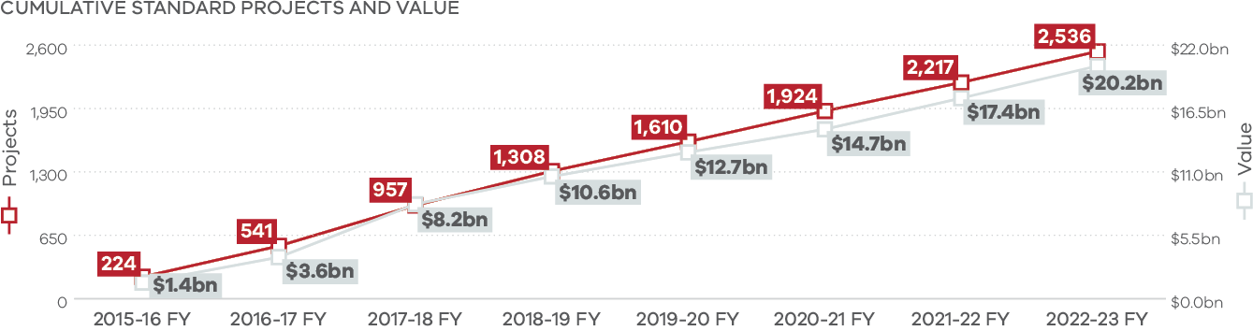

|  |  |  |
| --- | --- | --- |
|  | Projects | Value ($bn) |
| 2015-16 FY | 224 | 1.4 |
| 2016-17 FY | 541 | 3.6 |
| 2017-18 FY | 957 | 8.2 |
| 2018-19 FY | 1308 | 10.6 |
| 2019-20 FY | 1610 | 12.7 |
| 2020-21 FY | 1924 | 14.7 |
| 2021-22 FY | 2217 | 17.4 |
| 2022-23 FY | 2536 | 20.2 |

Local industry development plan commitments

* 78% average local content
* 43,556 jobs committed

62,756 opportunities for small to medium enterprises (SMEs)

A Standard Project is a project with a budget less than $50 million and greater than $1 million if it is regional, or greater than $3 million if it is statewide or in metropolitan Melbourne.

**Key highlights 2022‑23**

* 365 Commenced Local Jobs First projects
* Worth *$20.4 billion
* 144 Metro projects worth $8.5 billion
* 137 Regional projects worth $2.4 billion
* 84 Statewide projects worth $9.5 billion
* 46 Strategic projects
* 319 Standard projects
* 10,984 Jobs committed
* 24,339 opportunities for SMEs

* This figure represents the metro Melbourne, regional Victoria and Statewide figures rounded up.

* 145 Completed projects
* 72 Metro projects
* 67 Regional projects
* 6 Statewide projects
* 10 Strategic projects
* 135 Standard projects
* 3,570 Jobs committed
* 13,158 opportunities for SMEs
* Worth *$3.7 billion

* This figure represents the metro Melbourne, regional Victoria and Statewide figures rounded up.

Metro Melbourne

72 Completed projects worth $3.2 billion

Regional Victoria

67 Completed projects worth $478.5 million

Statewide

6 Completed projects worth $46.1 million

**Since its introduction in 2016 and 30 March 2023[1], the MPSG has been applied to 400 projects worth $164.8 billion and supported:**

* 400 MPSG Projects
* 5,478 Apprentices
* 2,530 Trainees
* 2,347 Cadets
* 10,355 total apprentices, trainees and cadets (ATCs)
* 15 million hours
* Metro MPSG projects have supported:
* 6,925 ATCs
* 12.7 million hours
* Regional MPSG projects have supported:
* 2,310 ATCs
* 1.7 million hours
* Statewide MPSG projects have supported:
* 1,043 ATCs
* 579,306 hours

1. About Local Jobs First

Local Jobs First is designed to:

* promote employment and business growth by expanding market opportunities for local industry
* provide contractors with increased access to, and raised awareness of, local industry capability
* expose local industry to world’s best practice in workplace innovation, e‑commerce and use of new technologies and materials

develop the international competitiveness and flexibility of local industry to respond to changing global markets by providing it with a fair opportunity to compete against foreign suppliers.

Local Jobs First supports Victorian businesses and workers by ensuring that small and medium‑sized enterprises (SMEs) are given a full and fair opportunity to compete for both large and small government contracts, helping to create job opportunities, including for apprentices, trainees and cadets (ATCs).

The *Local Jobs First Act 2003* (the Act) together with the Local Jobs First Policy and associated guidelines provide the regulatory framework, procedures and guidance for implementation of Local Jobs First.

Local Jobs First comprises both the Victorian Industry Participation Policy (VIPP) and Major Projects Skills Guarantee (MPSG).

* VIPP focuses on creating opportunities for local suppliers to compete for work on all types of government contracts, helping to create and sustain opportunities for local businesses and workers.

MPSG focuses on providing opportunities to Victorian ATCs to work on high value government construction projects.

Local Jobs First must be applied to regional projects worth more than $1 million, and state‑wide or metro Melbourne projects worth at least $3 million. Under VIPP, local content requirements are set by the Minister for Jobs and Industry for all government projects worth $50 million or more.

The MPSG automatically applies to construction projects at or over $20 million in value. From design and planning to steel fabrication, welding, and plumbing, MPSG requires the contractor to invest in our future workforce by ensuring that Victorian ATCs are engaged for a minimum of 10% of the total number of estimated labour hours on the project.

The Local Jobs First Commissioner is established under the Act and is responsible for advocating for the Local Jobs First Policy and facilitating greater involvement from local businesses, workers and ATCs. The Commissioner’s compliance and enforcement powers also help to ensure that agencies and contractors involved in government procurement understand and deliver on their obligations under the Act.

In October 2022, the Local Jobs First Policy, Agency Guidelines and Supplier Guidelines were updated and refreshed to strengthen policy outcomes and simplify application for agencies and industry. The changes included improved guidance and processes for the MPSG such as updated definitions of ATCs and a simplified approach to estimating labour hours. Along with the updated documents, a summary of the changes was provided on the Local Jobs First website.

The Local Jobs First legislation requires that all departments and agencies subject to the *Financial Management Act 1994* report on their implementation of Local Jobs First by providing:

* a detailed report on Local Jobs First implementation as part of their required annual reporting arrangements

a consolidated report to the responsible Ministers to enable the Ministers to report annually to Parliament.

Using the data provided by departments and agencies, this Annual Report presents the outcomes as they relate to Local Jobs First activities across government for the 2022‑23 financial year.

### Case study 1:

**Local Jobs First Supporting Local Manufacturing**

Woods Furniture, a local company based in Brooklyn, Victoria is not just a school furniture supplier; they are deeply committed to protecting the environment and ensuring a sustainable future for generations to come. The company emphasises that environmental protection is not only a process within their business but a way of life. They consider the environmental impact at every stage of their business operations, including renewable energy use, rainwater harvesting, partnering with like‑minded suppliers, recycling, and waste minimisation.

By manufacturing their products in Melbourne’s inner west and partnering with local authorities like the Victorian School Building Authority, Woods Furniture is not only contributing to the education sector but also supporting the local economy and community.

Thanks to the Local Jobs First Policy and their commitment to local manufacturing and dedication to environmental responsibility, Woods Furniture was selected to furnish North Melbourne Primary School’s innovative vertical campus project that opened early in 2023. The furniture supports adaptable teaching and learning approaches that are crucial in today’s rapidly evolving educational landscape.

1. Implementation of Local Jobs First
   1. Local Jobs First Commissioner

The Local Jobs First Commissioner advocates for local businesses, workers and ATCs, ensuring that they continue to benefit from Victorian Government procurement. By connecting with local industry, contractors, and government agencies applying the Local Jobs First Policy, the Commissioner educates stakeholders about the Local Jobs First Policy and assists with maximising outcomes for Victorian businesses and workers on government projects.

As part of the role, the Commissioner undertakes compliance activities to ensure that local businesses and workers are provided with a full and fair opportunity to participate in Local Jobs First projects and that suppliers are delivering on their stated local content and jobs commitments.

Ms Moana Weir was appointed to the role of Local Jobs First Commissioner on 27 January 2022. In her time in the role, Ms Weir has led the Office of the Local Jobs First Commissioner (OLJFC) with a clear purpose to secure local industry growth, increase participation of local workers, and to deliver economic and social benefits for Victorians.

* 1. Message from the Local Jobs First Commissioner – Ms Moana Weir

The 2022 financial year has seen the OLJFC adopt a new approach across all Local Jobs First Strategic Projects, focused on 3 key pillars: engagement, education, and enforcement. Under this approach, the OLJFC prioritise project performance and government agency and contractor accountability. This has also proven to be effective in mitigating risk and ensuring the prevention of non‑compliance.

Under this expanded approach, the OLJFC has conducted 100 Local Jobs First project meetings and engaged with 80 of the current 120 Local Jobs First Strategic Projects currently in execution phase, including 18 of the top 20 by project value.

This engagement enables the OLJFC to educate government agencies and their contractors in real‑time while also improving the understanding and effective implementation of the Local Jobs First Policy across projects under the Commissioner’s remit. This means more successful Local Jobs First projects and stronger compliance outcomes.

In addition to this, the OLJFC continues to conduct its audit program, and to engage with project delivery teams on the implementation of appropriate management action plans to address any gaps in compliance identified through the audit process.

Beyond our strengthened engagement within the expanded Local Jobs First Strategic Project remit, my engagement with industry stakeholders during the 2022‑23 financial year has included the facilitation of, or attendance at sector specific forums, including steel forums. It has also included speaking about the Local Jobs First Policy and my role to government agencies and industry at Department and external SME forums.

Through its enhanced strategic focus on Local Jobs First project engagement, education and enforcement, the OLJFC maximises the value delivered by the Local Jobs First Policy. This helps with securing local industry growth and increasing the participation of local ATCs, while proactively preventing and mitigate the risk of non‑compliance.

The OLJFC will continue its work in enabling growth in the capacity, capability, and resilience of local industry, delivering economic and social benefits for Victorians.

**Moana Weir**Local Jobs First Commissioner

* 1. Industry Capability Network Victoria

The Industry Capability Network (ICN) is a not‑for‑profit organisation that supports the Department of Jobs, Skills, Industry and Regions (DJSIR) with the implementation of the Local Jobs First Policy. It also assists Victorian Government departments, agencies, and businesses to comply with the requirements of the policy.

The ICN plays a key role in liaising with Victorian Government departments, agencies, and industry. The ICN provides support to businesses completing Local Industry Development Plans (LIDPs) and also supports the link between principal contractors and local SMEs through its’ significant local industry knowledge.

ICN’s engagement with local SMEs via the ICN Gateway, an online portal for suppliers to register their interest in supplying into Local Jobs First projects, builds understanding of local industry capabilities. In addition, the ICN also manages the Victorian Management Centre (VMC) for Local Jobs First where agencies register as well as monitor and report on Local Jobs First projects.

With the continued increase in Local Jobs First projects in 2022‑23, the ICN reported a continuation of strong engagement activities with local SMEs, departments, and agencies including project contestability assessments and LIDP acknowledgements. ICN delivered 22 project industry and policy briefing sessions in the 2022‑23 financial year, connecting more Victorian businesses to government project opportunities. Events were held in metro Melbourne, Ballarat, Geelong, Horsham, and Bendigo, and included both virtual and in person formats.

* 1. Department of Jobs, Skills, Industry and Regions

DJSIR’s role in administering the Act includes developing the Local Jobs First Policy, guidelines and model clauses, as well as establishing structures to support delivery of the policy across Victorian Government departments and agencies. As part of this, DJSIR monitors and reports on implementation of the Local Jobs First Policy and provides regular advice and reporting to the responsible Minister and the Victorian Government as a whole regarding operation of the Local Jobs First Policy.

In addition, DJSIR is responsible for:

* working with agencies and the ICN to set Local Jobs First requirements on Strategic Projects
* managing the services delivered by the ICN under the Local Jobs First Policy
* leading engagement with the Commonwealth Government, other states and territories, and internationally, on the Local Jobs First Policy

preparing whole of government reporting on the application of the Local Jobs First Policy.

For further details, please refer to the [Local Jobs First website](https://localjobsfirst.vic.gov.au/).

### Case study 2:

**MPSG delivers on the Keon Parade Level Crossing Removal Project**

Hesham Al‑Sharafi is a Civil Engineer employed through the Engineering Pathways Industry Cadetship (EPIC), who has been working on the Keon Parade Level Crossing Removal Project.

EPIC is an 18‑month program for refugee and asylum seeker engineers working on major transport infrastructure projects. The industry‑first program aims to bridge the gap faced by new Australians in matching their international qualifications to Australian workforce requirements. EPIC employees receive on‑the‑job training, support and mentoring, and also complete a postgraduate degree through Swinburne University (Graduate Certificate in Infrastructure Engineering Management).

Hesham couldn’t stay in his home country of Yemen due to the civil war, so he travelled to Malaysia to finish his studies in Engineering. Since its inception, there have been 73 EPIC cadets employed across the transport infrastructure industry, with the third cohort of 21 cadets having joined in February 2023. Hesham arrived in Sydney 4 years ago, and took various jobs outside of his preferred field of civil engineering. Hesham applied for the EPIC program in Melbourne as it provided him an avenue to transition into the civil engineering field in Australia, while gaining on‑the‑job experience. Since January 2023, he has been working on the Keon Parade level crossing removal project in Melbourne’s north. The future is now looking brighter for Hesham as he hopes to soon reunite his family in Australia. “My family are still there in Yemen and I’m trying to apply for them to come here too.”

The MPSG helps to provide opportunities to ATCs like Hesham on some of Victoria’s major projects ensuring that the next generation have access to good, secure jobs on some of Victoria’s most important projects through the Local Jobs First Policy.

1. Local Jobs First Outcomes in 2022‑23

Under the Local Jobs First Policy, each project is designated as either a Standard Project or a Strategic Project based on the project value and/or Ministerial determination.

As Victoria’s infrastructure spending has increased in recent years, the number and value of Local Jobs First Standard and Strategic Projects has reached record levels. The strong pipeline of current and future projects will continue to generate opportunities for local industry over the next decade and beyond.

* 1. Strategic Projects

Since November 2014 to 30 June 2023, minimum local content requirements have been set on a total of 300 Local Jobs First Strategic Projects, with a combined value of $144.6 billion. These projects are expected to deliver an average of 88% local content, provide more than 50,000 jobs, and provide tens of thousands of opportunities for local SMEs to get involved in large Victorian Government projects.

In 2022‑23 alone, the Victorian Government set local content requirements for 48 Strategic Projects. This is a near‑record and is only 7 projects less than the record set in 2021‑22 where 55 Strategic Projects had Local Jobs First requirements set. The 48 Strategic Projects are worth just over $26 billion collectively – representing a record high in terms of government investment in a financial year. These projects received an average minimum local content requirement of 78%.

The types of projects with Ministerial requirements set are diversifying – with a record number of service projects in 2022‑23. Of the 48 Strategic Projects that had minimum requirements set, 16 (33% of all projects) were services projects. This continues a trend that began in 2017‑18, where 65% of projects were construction and services projects accounted for 11% of all projects, increasing into the mid‑teens over subsequent years. While the overall local content requirement is lower this year than in previous years, this is due to the higher percentage of services projects. Construction projects that had Ministerial requirements set in 2022‑23 received a minimum local content of 93%, an increase on previous years.

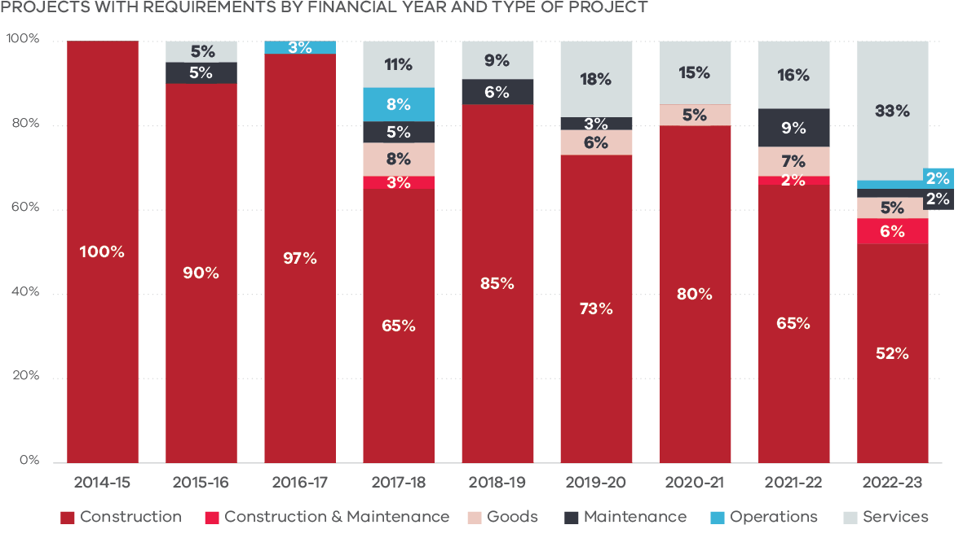

|  |  |  |  |  |  |  |
| --- | --- | --- | --- | --- | --- | --- |
|  | Construction | Construction & Maintenance | Goods | Maintenance | Operations | Services |
| 2014-15 | 100% | – | – | – | – | – |
| 2015-16 | 90% | – | – | 5% | – | 5% |
| 2016-17 | 97% | – | – | – | 3% | – |
| 2017-18 | 65% | 3% | 8% | 5% | 8% | 11% |
| 2018-19 | 85% | – | – | 6% | – | 9% |
| 2019-20 | 73% | – | 6% | 3% | – | 18% |
| 2020-21 | 80% | – | 5% | – | – | 15% |
| 2021-22 | 65% | 2% | 7% | 9% | – | 16% |
| 2022-23 | 52% | 6% | 5% | 2% | 2% | 33% |

Please refer to the Local Jobs First website for full project details at: [Local Jobs First/Strategic Projects](https://localjobsfirst.vic.gov.au/projects/strategic-projects).

**Breakdown of Metro, Regional and Statewide Projects over 2022‑23**

**Metro Melbourne**

* 144 Commenced projects
* 120 Standard projects
* 24 Strategic projects
* Worth $8.5 billion
* 4,188 Jobs committed
* 10,213 opportunities for SMEs
* 59% average local content*
* 72 Completed projects
* 63 Standard projects
* 9 Strategic projects
* Worth $3.2 billion
* 2,352 Jobs committed
* 8,201 opportunities for SMEs

82% average local content

**Regional Victoria**

* 137 Commenced projects
* 128 Standard projects
* 9 Strategic projects
* Worth $2.4 billion
* 2,448 Jobs committed
* 7,345 opportunities for SMEs
* 62% average local content*
* 67 Completed projects
* 66 Standard projects
* 1 Strategic projects
* Worth $440.1 million
* 1,132 Jobs committed
* 4,617 opportunities for SMEs

72% average local content

**Statewide**

* 84 Commenced projects
* 71 Standard projects
* 13 Strategic projects
* Worth $9.5 billion
* 4,348 Jobs committed
* 6,781 opportunities for SMEs
* 40% average local content^
* 6 Completed projects
* 6 Standard projects
* 0 Strategic projects
* Worth $309.1 million
* 85 Jobs committed
* 340 opportunities for SMEs
* 47% average local content^

* Projects commencing in the 2022‑23 financial year recorded a lower average local content because of more service projects commencing, with these projects usually recording lower local content than construction projects. Projects commencing are also at an earlier stage of development, with not all tenders awarded.

^ Statewide Projects have a higher proportion of services projects, which have lower local content to other types of projects.

### Case study 3:

**Frankston Hospital Redevelopment Project**

The Frankston Hospital redevelopment is being delivered as a public‑private partnership by the Victorian Health Building Authority, Peninsula Health and the Exemplar Health consortium. The $1.1 billion project will deliver a new tower with 12‑stories of clinical services and a new main entrance, 130 more beds, new spaces for mental health and oncology services, and 15 new operating theatres. Construction is underway, with the onsite workforce increasing 2024 and the main works expected to be completed in 2025.

Exemplar Health’s design and construction contractor, Lendlease, has made commitments in response to the strong Local Jobs First requirements set for the project that will create significant opportunities for local businesses and workers. With around 2 years of main works remaining, 68 ATCs (nearly 30% female) have contributed to the project across 13 different qualifications, contributing significantly to the MPSG commitments for the project.

Exemplar Health launched an integrated workforce development and social procurement program for the Frankston Hospital redevelopment called The Exchange. It promotes, coordinates, and achieves employment and skilling opportunities for people disadvantaged in the job market and supports local workforce and business needs across the Frankston and Mornington Peninsula community networks.

Through The Exchange, Lendlease welcomed 8 Aboriginal and Torres Strait Islander trainees into it’s Be Onsite program. This is a hands‑on program aiming to build workforce confidence for people who experience barriers to sustainable employment and is designed to empower and support trainees with essential skills and knowledge. The MPSG provides significant opportunities for ATCs to work on high‑value construction projects and the Frankston Hospital redevelopment is another great example of how Local Jobs First can help to kickstart the careers of job seekers.

**Local businesses benefiting from the Frankston Hospital Redevelopment Project**

Working with SMEs from the local area has been a key priority on the project from the outset. To date, 48 local businesses have been directly contracted by Lendlease and many more through its subcontractor and supplier network.

The Frankston Hospital redevelopment demonstrates how Local Jobs First and the Victorian Government’s Social Procurement Framework combine to deliver opportunities for local businesses.

Lendlease has engaged with local business through both the ICN and local social benefit suppliers through engagement with the Frankston Social Enterprise Hub. This engagement has included assisting with the development of procurement plans with subcontractors and suppliers or featuring businesses, including Panku, a local indigenous personal protective equipment (PPE) supplier, at a ‘meet the supplier’ event.

Thanks to gaining work on the Frankston Hospital redevelopment project, Panku has obtained further work on government projects and has now cemented itself in various supply chains with frequent opportunities for PPE orders. Panku has then reinvested in the supply chain by supporting local jobs and businesses and in community by engaging with the Koori Academy Melbourne and Budadee Ranger Program which provide training and employment for remote communities.

* 1. Commenced Projects

A total of 365 Local Jobs First projects worth $20.4 billion commenced during 2022‑23. This includes 144 metro Melbourne projects, 137 regional projects and 84 statewide projects. Of the 365 projects, 46 were Strategic Projects and 319 were Standard Projects. Together, these projects have committed to delivering 10,984 jobs and 24,339 opportunities for local SMEs.

Since 2015, the Local Jobs First Policy has been applied to 2,536 Standard Projects worth $20.2 billion. In 2022‑23, 319 Standard Projects worth a total of $2.8 billion commenced, with 128 of these being delivered in regional Victoria. These projects will provide opportunities for 18,152 local SMEs and support 5,682 jobs.

* 1. Completed Projects

During 2022‑23, 10 Local Jobs First Strategic Projects worth a total of $2.7 billion were completed.

This brings the total to 72 Local Jobs First Strategic Projects that have been reported as complete by agencies since November 2014, worth a combined value of $16 billion.

A total of 135 Standard Projects, valued at $959 million, were completed in 2022‑23. Of these completed projects, 66 were in regional Victoria.

Please see Appendix A for a list of the completed Strategic Projects throughout 2022‑23.

* 1. Major Projects Skills Guarantee

Since its introduction in 2016, the MPSG has been applied to 400 projects collectively worth $164.8 billion, which have committed to 21.4 million contracted hours for 6,212 ATCs. This includes 104 regional projects that have committed to over 2.1 million hours for 810 ATCs.

* 1. Local Content

All Local Jobs First projects require an LIDP outlining the items that are contestable (both international and local providers) and the businesses that will be engaged to deliver different elements of the project, providing opportunities for local industry and workers. Local content includes goods produced, services supplied, and construction activities carried out, by local industry. The local assembly of imported materials, transport of goods, and local labour are all examples of local content or local added value.

‘Local’ is defined as businesses in Australia and New Zealand producing goods, providing services or construction activity, and when local content has been added to imported items through activities such as assembly or installation.

In 2022‑23, 1,318 tenders were registered with the ICN. A total of 3,760 LIDPs were prepared by businesses in bidding for Local Jobs First projects.

* 1. Grants

Grant and loan recipients are required to apply the Local Jobs First Policy, where the value of the grant meets the Local Jobs First financial thresholds and the recipient is not a State or Commonwealth government agency. Recipients of the relevant grants must engage with the ICN to discuss opportunities for local SME involvement.

During 2022‑23, a total of 189 grants were registered with the ICN.

* 1. Exemptions

Under section 4A (3) of the Act, the Minister for Jobs and Industry may exempt a government department or agency from the requirements of the Local Jobs First Policy if exceptional circumstances apply.

There have been no exemptions granted in the 2022‑23 financial year.

### Case study 4:

**Local Jobs First is delivering opportunities for young Victorian manufacturers**

The Local Jobs First Policy is providing career opportunities for our next wave of advanced manufacturers. At the recent Victorian Manufacturing Hall of Fame event, Alstom’s Swastik Sharma was recognised as the 2023 Victorian Young Manufacturer of the Year.

As a 2020 Monash University Industrial Engineer graduate, Swastik is employed at Alstom’s Dandenong South facility, which is a major centre of Victorian rail and tram rolling stock manufacturing.

As well as producing metropolitan and regional trains, this world class facility will soon start building Melbourne’s next‑generation G Class trams, which will have a minimum local content requirement of 65%.

After first joining Alstom, Swastik initially worked on special projects investigating the feasibility of new technologies like additive manufacturing and virtual reality. He now has a leading role in Alstom’s first Australian Additive Manufacturing Hub, which will provide 3D printing services for Victorian Government rolling stock projects including Melbourne’s new G Class trams and the new X’Trapolis metropolitan trains being built in Ballarat.

# Local Jobs First Highlights

* 1. Strategic Project Records and Milestones

It was another busy year in 2022‑23, with requirements set for 48 Local Jobs First Strategic Projects. This is just 7 less than last year’s record of 55 Strategic Projects. These 48 projects, collectively valued at over $26 billion, represent the highest value of Strategic Projects with requirements set in a year. The requirements set on these projects will provide significant opportunity for local businesses and workers, including local ATCs to be involved and benefit from this significant investment.

In 2022‑23, Victoria reached 300 Strategic Projects that have applied the Local Jobs First Policy since 2014. These projects have committed to support more than 50,000 local jobs. This includes a commitment to provide 14.6 million contracted hours to Victorian ATCs helping to form the next generation of skilled Victorian workers.

* 1. Additional Requirements set for Strategic Projects

Additional local content requirements have continued to be set and strengthened on Strategic Projects through the 2022‑23 financial year by the Minister for Jobs and Industry. This has included working with other areas of government and leveraging other industry participation and development policies and programs. Setting additional requirements has ensured future projects continue to develop local industries, create jobs and boost economic activity across Victoria.

In 2022‑23, additional requirements were set on 38 projects with a total of 102 additional requirements. These additional requirements are ensuring local production, businesses, research, and other valuable economic activities are incentivised and considered throughout the life of Local Jobs First projects.

These additional requirements include:

* A more refined and targeted approach to setting minimum local content requirements and/or the development of an engagement or sourcing plan for steel and development of an approach to mitigate offshoring of steel sourcing and fabrication by ensuring suppliers are given advanced notice of upcoming opportunities
* Further strengthening of Australian MedTech requirements, including the development of non‑targeted requirements such as a sourcing plan designed to increase project opportunities for engagement with local suppliers
* Further strengthening minimum local content requirements for fittings, fixtures, and equipment (FF&E) and when appropriate by separating out Information, Communications and Technology (ICT) equipment to maximise the outcome for construction related FF&E. Targeted requirements have also been set particularly for health, education and housing projects and other building projects

To complement these and other additional local content requirements the Local Jobs First Policy was updated to strengthen the application of LIDPs, which covers anything that is considered a significant diversion from any item listed within the LIDP, with a particular focus on steel, as well as other materials to ensure agencies and head contractors are aware of their obligations.

### Additional requirements since 2015‑16

Since 2015, 349 additional requirements were set on 138 Strategic Project worth $87.1 billion.

### Additional requirements set during 2022‑23

In 2022‑23, 102 additional requirements were set on 38 Strategic Projects worth $23.9 billion.

### Case study 5:

**Zero‑emission buses**

As Victoria takes the first steps towards a Zero Emission Bus (ZEB) fleet, the Victorian Government is ensuring that strong support for local jobs and industry is maintained.

The $20 million investment in the ZEB trial will increase industry collaboration and help drive innovation, research and development to increase local capability in this emerging field.

By setting strong Local Jobs First requirements, this has helped the project support local industry and 6 existing bus operators have been chosen to run trials of both battery electric buses and hydrogen fuel cell buses over 3 years.

In parallel, Melbourne‑based bus operator Kinetic has benefited from the Local Jobs First Policy and is rolling out 36 ZEBs through the $2.3 billion Metropolitan Bus Franchise project. The buses are being built locally at Volgren’s Dandenong South facility, with a minimum 60% local content on the entire project, and a minimum 90% local content required for the operations phase.

Both the ZEB trials and the Kinetic contract are helping to identify the risks and opportunities of new technologies and are informing the future transition of all 4,500 public buses. From 2025, the Victorian Government has committed to only purchasing ZEBs as Victoria’s stock of diesel buses are retired.

* 1. Industry Impacts of Steel and FF&E Requirements

The inclusion of additional requirements focusing on the use of steel and FF&E are having an impact, with the number of these businesses operating in Victoria increasing significantly in recent years. FF&E and steel have been areas of focus for the Victorian Government for a number of years – the first specific Local Jobs First requirement for steel was set in 2015, with the first specific requirement for FF&E set in 2019.

### Furnishings, Fixtures and Equipment

Since 2015, FF&E requirements have been set on 55 Strategic Projects. The total value of these projects is $15.6 billion. Since 2010, Victoria has gained 25,350 FF&E businesses, increasing 2.6% annually. This has resulted in Victoria’s share of FF&E businesses in Australia increasing – from 27% in 2010 to over 30% in 2022.

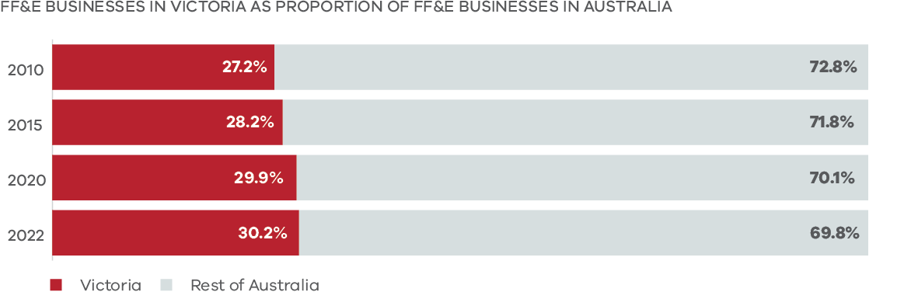

|  |  |  |
| --- | --- | --- |
|  | Victoria | Rest of Australia |
| 2010 | 27.2% | 72.8% |
| 2015 | 28.2% | 71.8% |
| 2020 | 29.9% | 70.1% |
| 2022 | 30.2% | 69.8% |

### Steel

Since 2015, steel requirements have been set on 78 Strategic Projects. The total value of these projects is $38.1 billion. Since 2010, Victoria has gained 23,218 steel businesses, increasing 1.9% annually. This has resulted in Victoria’s share of steel businesses in Australia increasing – from 23% in 2010 to 25% in 2022.

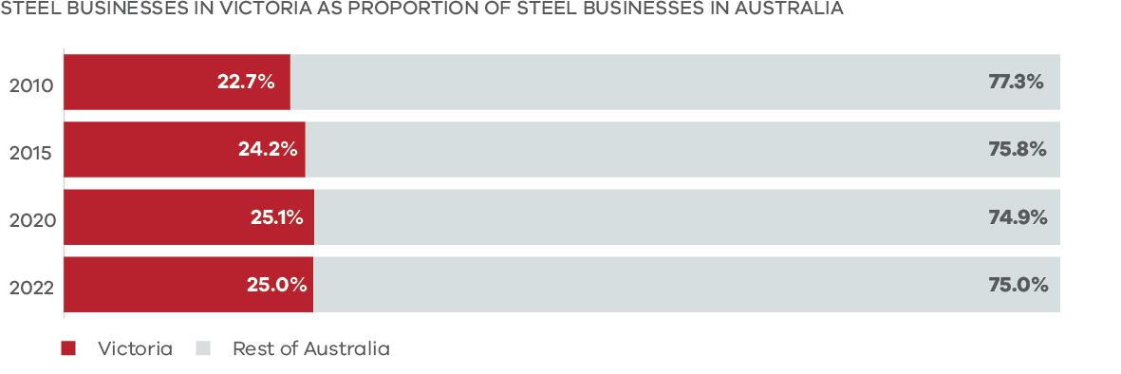

|  |  |  |
| --- | --- | --- |
|  | Victoria | Rest of Australia |
| 2010 | 22.7% | 77.3% |
| 2015 | 24.2% | 75.8% |
| 2020 | 25.1% | 74.9% |
| 2022 | 25.0% | 75.0% |

### Case study 6:

**North East Link**

The North East Link project is delivering Victoria’s longest road tunnels from Watsonia to Bulleen. Through the Local Jobs First Policy, the lead contractor, the Spark Consortium has committed to supporting 500 Victorian businesses, allowing them to grow through the supply of goods and services to the project. One of these businesses is Pathway Plumbing.

Pathway Plumbing is a Victorian business that was registered in 2021 and is a Kinaway certified Aboriginal business. They provide skilled labour to perform plumbing works, gas fitting, installation and servicing of equipment. Through gaining work on the North East Link, this has provided them with a stable pipeline of work to support their current apprentices and enables them to recruit 4 more young Aboriginal apprentices.

One of these is a young First Nations man named James, who was initially hired for a 12‑month period to be a plumber’s assistant. After successfully completing the 12-month period, James committed to a 4‑year apprenticeship. James has flourished with the support provided by Pathway Plumbing and is now in his 3rd year, only 1 year away from completing his qualification.

Over the course of the last 3 years, this job has brought James stability which has been extremely beneficial for his health, wellbeing and family. James has been able to purchase his first car, first house and recently had his first child.

* 1. Local Jobs First Standard Projects

It was another strong year for Local Jobs First Standard Projects with 319 projects valued at $2.8 billion being registered. As with Strategic Projects, Standard Projects also provide significant opportunities for local businesses and workers. As at 30 June 2023, the number of Standard Projects totalled 2,536 and were collectively valued at $20.2 billion.

For Strategic Projects, the Minister for Jobs and Industry sets Local Jobs First requirements that successful contractors must meet. In contrast, Standard Projects involve a more market‑led approach where bidders must outline in their tender response:

* industry development commitments (local content, technology transfer, supply chain engagement)
* jobs outcomes commitments (new and retained jobs, training) including MPSG commitments where applicable
* detailed information about how the LIDP will be implemented including the management of risks, industry engagement strategies, and the selection and benchmarking of local content
* monitoring and reporting requirements, including those to be delivered as part of project management procedures

the number of SMEs that will be engaged as part of the contract.

The ICN can work with bidders to help them respond to tenders. The ICN also provides a range of other assistance to bidders, including helping them to identify local capability for a particular item or set of items, and advising bidders where further detail in the LIDP may be required.

Once all LIDPs for a tender are completed, a separate area of the ICN then reviews the LIDPs and provides a report to the Victorian Government delivery agency. The report must be used in the agency’s tender evaluation process. Under the Local Jobs First Policy, 2 mandatory 10% weightings for both industry development and jobs outcomes must be incorporated by the agency into the tender evaluation. This helps to ensure bids with ambitious Local Jobs First proposals are more likely to be successful.

An example of a Standard Project is the supply and delivery of continence, wound care and nutritional products, a project undertaken by WorkSafe Victoria. Following a contestable outcome undertaken by the ICN, it was determined that goods and/or services required for this tender were available from competitive local and international manufacturers and/or suppliers. As a result BrightSky Australia, a company that supports Victorian based social enterprises, was awarded the contract to supply the required products.

Further information about Standard Projects and the Local Jobs First Policy can be found at [Local Jobs First](http://www.localjobsfirst.vic.gov.au/).

# Appendix A: Completed Strategic Projects for 2022‑23

| Project | Local Jobs First requirements | Region |
| --- | --- | --- |
| Wonthaggi Hospital Expansion Project | 90% minimum local content for the project. | Gippsland |
| Level Crossing Removal at Hallam Road, Hallam – Part of South Eastern Program Alliance* | 89% minimum local content. 100% local steel. | Metropolitan Melbourne |
| Glenroy Road, Glenroy Grade Separation – Part of the North Western Program Alliance | 89% minimum local content. 100% local steel. | Metropolitan Melbourne |
| Cranbourne Line Duplication (Package B) – Part of South Eastern Program Alliance* | 89% minimum local content. 100% local steel. | Metropolitan Melbourne |
| Cranbourne Line Upgrade (Package A) – Part of Western Program Alliance | 93% minimum local content for the project. 100% local steel. | Metropolitan Melbourne |
| Level Crossing Removals at Manchester Road, Mooroolbark and Maroondah Hwy, Lilydale – Part of South Eastern Project Alliance* | 89% minimum local content. 100% local steel. | Metropolitan Melbourne |
| AWP2 Aviation Road – Part of Western Program Alliance | 93% minimum local content for the project. 100% local steel. | Metropolitan Melbourne |
| Program A – Narre Warren North Road Upgrade | 96% minimum local content for the project. All consultants including but not limited to architects, designers, engineers and other advisers must preference solutions that maximise the use of local materials, fittings, finishes, products, goods and services in construction including fixtures and equipment wherever possible. | Metropolitan Melbourne |
| Program C – Monash Freeway Upgrade Stage 2 – Part of Monash Freeway (M1) Upgrade – Stage 2 | 96% minimum local content for the project. | Metropolitan Melbourne |
| Program A – Western Port Highway Upgrade Project | 97% minimum local content for the project. All consultants including but not limited to architects, designers, engineers and other advisers must preference solutions that maximise the use of local materials, finishes, products, goods and services in construction including fittings, fixtures and equipment wherever possible. | Metropolitan Melbourne |

* South Eastern Project Alliance use the Ministerial requirements set for the North Eastern Program Alliance.

1. MPSG Commitments and outcomes are reported separately to the annual report and include pre‑award, commenced, ongoing and completed projects. Unlike figures elsewhere in this report, these figures are cumulative and are not exclusively from the 2022‑23 financial year. The region type (metro, regional or statewide) was not available for 2 projects. These 2 projects achieved 77 ATC positions and 24,818 hours to date.