LOCAL JOBS FIRST VICTORIAN INDUSTRY PARTICIPATION POLICY ANNUAL REPORT 2018-19

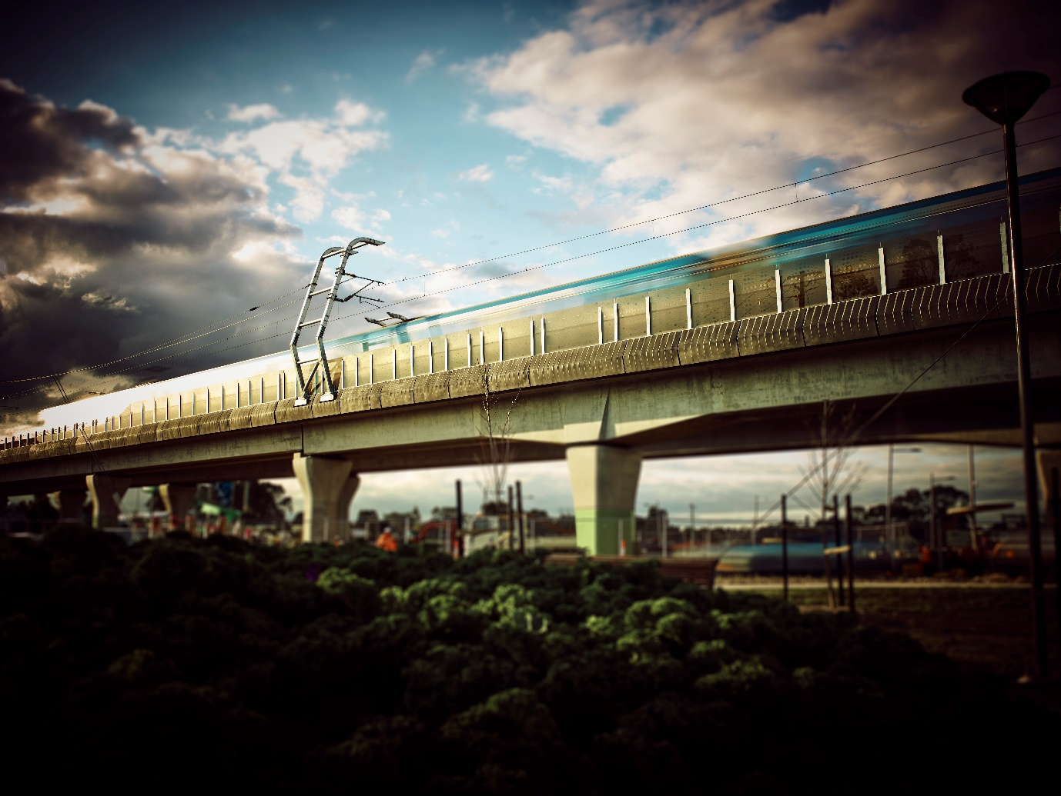
1 Noise walls on Caulfield to Dandenong Level Crossing Removal Project
Viscount Rotational Mouldings, a local Carrum Downs based manufacturer, has developed new innovative noise walls that have been used on the Monash Freeway Redevelopment and the Caulfield to Dandenong Level Crossing Removal Project Local Jobs First Strategic Projects.
The new noise walls have a lower carbon footprint than traditional concrete walls, made from locally supplied resins and are fully recyclable at end of life.
(Photo credit: Pact Group)

Local Jobs First at a glance
Since 2014, the Local Jobs First Policy has been applied to 126 Strategic Projects,worth $65 billion
In Regional Victoria, the Local Jobs First Policy
- supported 6,213 local jobs
- applied to 222 projects
- covered $1.3 billion of projects
- 1,306 SMEs involved in projects in Regional Victoria
In Metropolitan Victoria, the Local Jobs First Policy
- supported 8,926 local jobs
- applied to 258 projects
- covered $3.8 billion of projects
- 1,272 SMEs involved in projects in Metropolitan Victoria
In 2018-19 345 projects covered by Local Jobs First commenced, 223 were completed, 16,711 jobs and 2,697 SMEs supported. 1,059 positions for apprentices, trainees and cadets supported by Local Jobs First projects that commenced in 2018-19
86 per cent average Local Content Committed for Projects that commenced in 2018–19
86 per cent average Local Content Achieved for per cent Projects that were completed in 2018–19
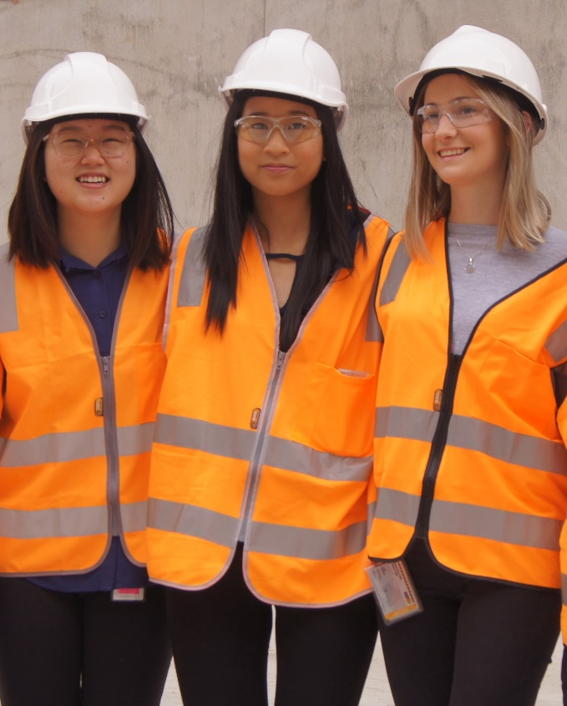

2 Trainees on Melbourne Metro Tunnel Project
The Local Jobs First – Major Projects Skills Guarantee ensures that young Victorian benefit directly from major Victorian infrastructure projects and ensures that we continue to grow the next generation of skilled workers in Victoria.
(Photo credit: Metro Tunnel Project)
Contents
Local Jobs First at a glance 2
Local Jobs First in Metropolitan Victoria 2018-19 4
Minister’s Foreword 5
1 Local Jobs First 6
1.1 Local Jobs First Act 2003 6
1.2 Local Jobs First – Victorian Industry Participation Policy 7
1.3 Local Jobs First – Major Projects Skills Guarantee 7
Local Jobs First Commissioner 7
1.4 Industry Capability Network (Victoria) – supporting day to day implementation of Local Jobs First 8
1.5 Local Jobs First Commissioner’s message 8
Local Jobs First in Regional Victoria 2018-19 9
2 Local Jobs First – outcomes in 2018–19 9
2.1 Local Content 9
2.2 Local Jobs First Standard Projects 10
2.3 Local Jobs First Strategic Projects 10
2.4 Local Jobs First Strategic Projects – completed 17
2.5 Local Jobs First – Major Projects Skills Guarantee 18
2.6 Grants 18
Local Jobs First in Statewide 2018-19 19
3 Local Jobs First - Compliance 19
3.1 Engagement and awareness 19
3.2 Compliance reporting 19
DISCLAIMER 20

Local Jobs First in Metropolitan Victoria 2018-19
8,926 jobs supported across Metropolitan Victoria
1,272 SMEs involved in projects across Metropolitan Victoria
Northern Metro
- 25 projects
- $666 million
- 1,343 jobs supported by projects
- 111 SMEs getting work
- 88% average local content
Inner Metro
- 166 projects
- $2.4 billion
- 6,090 jobs supported by projects
- 563 SMEs getting work
- 82% average local content
Eastern Metro
- 17 projects
- $160 million
- 548 jobs supported by projects
- 42 SMEs getting work
- 78% average local content
Western Metro
- 16 projects
- $159 million
- 249 jobs supported by projects
- 367 SMEs getting work
- 71% average local content
South Eastern Metro
- 25 projects
- $148 million
- 225 jobs supported by projects
- 82 SMEs getting work
- 92% average local content
These figures above include both commenced and completed projects. Specific location information not provided for nine Metro projects.
$2.4 billion worth of projects commenced in Metropolitan Victoria
$1.4 billion worth of projects completed in Metropolitan Victoria
145 projects commenced in Metropolitan Victoria
108 projects completed in Metropolitan Victoria
140 Standard Projects and 5 Strategic Projects commenced in 2018–19

Minister’s Foreword
On behalf of the Victorian Government, I am pleased to present the 2018–19 Local Jobs First Annual Report.
The Victorian Government is using our investment in goods, services and construction to support local businesses and help create jobs and opportunities for apprentices, trainees and cadets.
This is the first year of the strengthened Local Jobs First Policy, bringing together the Victorian Industry Participation Policy and the Major Projects Skills Guarantee (MPSG).
The Local Jobs First Policy requires that tenders for all Victorian Government Standard Projects (valued at $1 million or more in regional Victoria or $3 million or more in metropolitan Melbourne) include a Local Industry Development Plan identifying local content to be used on projects.
In addition, for Strategic Projects (valued at $50 million or above) minimum local content of 90 per cent for construction or 80 per cent for services, maintenance or operations, is mandatory.
The inaugural Local Jobs First Commissioner, Mr Don Matthews, was appointed in October 2018 and has made an enormous contribution already, advocating for Victorian industry involvement in Victorian Government projects and ensuring compliance with Local Jobs First.
Over the course of 2018–19, local content requirements were set for 33 Strategic Projects valued at over $8.1 billion, with a requirement to deliver an average of 92 per cent local content.
Also, in 2018–19, 220 Standard Projects were completed worth a total value of $1.8 billion. These completed Standard Projects supported more than 8,000 jobs, including over 1,500 apprenticeships, traineeships and cadetships.
Since its introduction in 2016, the MPSG has been applied to 116 projects which have committed to more than four million contracted hours for 3,700 apprentices, trainees and cadets.
Through Local Jobs First, Victoria’s public and transport infrastructure, construction, digital, services and other projects are creating local jobs and helping local businesses to grow our economy.
The Hon Martin Pakula MP
Minister for Jobs, Innovation and Trade

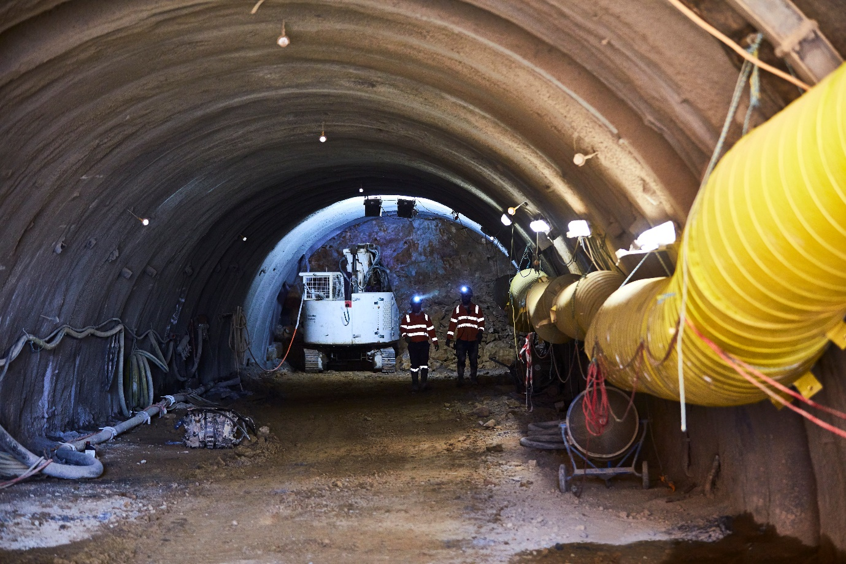
3 Tunnel on Level Crossing Removal Project
The Level Crossing Removal Project is removing 75 of Melbourne’s most dangerous and congested level crossings. During peak construction in June 2019 there were more than 6,00 workers across 18 sites.
Apprentices, trainees and cadets are also playing a huge part in Victoria’s pipeline of infrastructure projects, completing at least 10 per cent of work hours under the Victorian Government’s Major Projects Skills Guarantee.
(Photo credit: Level Crossing Removal Project)

Local Jobs First
The Victorian Government is the largest procurer of goods, services, and construction works in the State. The government is committed to using its substantial purchasing power to allow all Victorians to participate in the State’s economic future.

Local Jobs First Act 2003
The Local Jobs First Act 2003 (the Act), formerly known as the Victorian Industry Participation Policy Act 2003, is the longest standing and strongest industry participation legislation in Australia. The Act underwent significant reform in August 2018 to strengthen compliance and improve opportunities for local small and medium enterprises (SMEs) and workers.
The 2018 reforms:
- brought together Victoria’s signature industry participation and jobs policies, the Victorian Industry Participation Policy (VIPP) and the Major Projects Skills Guarantee (MPSG)
- mandated minimum local content requirements on projects valued at $50 million or more, including 90 per cent on construction projects and 80 per cent on service projects or operations activities
- mandated the use of local apprentices, trainees and cadets on construction projects valued at $20 million and above
- established a Local Jobs First Commissioner to advocate for Victorian businesses and workers and oversee compliance of Local Jobs First commitments
- established a compliance framework so that government and industry can be confident that the promised industry development and job commitments are delivered.
The legislation continues the requirement for all departments and agencies, that are subject to the Financial Management Act 1994, to report on their implementation of Local Jobs First in two ways:
- a detailed report on Local Jobs First implementation as part of departments’ and agencies’ normal annual reporting arrangements
- a consolidated report to the responsible Minister to enable the Minister to report annually to Parliament on the outcomes of Local Jobs First across government.
This Annual Report presents the outcomes as they relate to Local Jobs First activities for the 2018–19 financial year. It reflects the available data provided by departments and agencies for the financial year.
The Act is administered by the Office of Industry Participation and Jobs, in the Department of Jobs, Precincts and Regions (DJPR). This includes developing the Local Jobs First Policy, guidelines and model clauses and establishing structures to support its delivery across Victorian government departments and agencies. As part of this, the Office of Industry Participation and Jobs undertakes monitoring, reporting and auditing activities related to the Local Jobs First Policy.
For further details refer to localjobsfirst.vic.gov.au

Local Jobs First – Victorian Industry Participation Policy
Local Jobs First – VIPP ensures that SMEs are given a full and fair opportunity to compete for Victorian Government projects, such as the construction of hospitals, schools, road projects and the delivery of services or the provision of goods.
Local Jobs First – VIPP requires government departments and agencies to consider competitive local SMEs, when awarding projects valued at:
- $1 million or more in regional Victoria, or
- $3 million or more in metropolitan Melbourne or for statewide activities.
Projects that meet these thresholds are designated as Local Jobs First Standard Projects.
A Local Jobs First Strategic Project is a project with a budget of $50 million or more or any other project declared to be a Strategic Project by the Minister for Jobs, Innovation and Trade.

Local Jobs First – Major Projects Skills Guarantee
Local Jobs First – MPSG ensures that apprentices, trainees and cadets are provided an opportunity to work on Victoria’s biggest infrastructure projects.
Local Jobs First – MPSG requires government departments and agencies to ensure their suppliers on construction projects valued at $20 million or more are utilising apprentices, trainees and cadets for a minimum 10 per cent of the total labour hour.

Local Jobs First Commissioner
The inaugural Local Jobs First Commissioner is Don Matthews.
The Local Jobs First Commissioner’s responsibilities and functions are effective as of 16 August 2018 and are applicable to all projects from this time.
The Local Jobs First Commissioner promotes the Local Jobs First Policy across departments, agencies and local industry, advocates on behalf of Victorian SME’s and promotes the employment of apprentices, trainees and cadets on government projects. The role also oversees compliance of local content and job commitments entered into as part of the contractual arrangements for project delivery.

Industry Capability Network (Victoria) – supporting day to day implementation of Local Jobs First
The Industry Capability Network (Victoria) Ltd (ICN) is a not-for-profit organisation that supports DJPR with the implementation of Local Jobs First and assists Victorian Government departments, agencies and businesses to comply with the conditions of Local Jobs First.
ICN plays a key role in liaising with Victorian Government departments, agencies and industry by providing support to businesses to complete their Local Industry Development Plans (LIDP) (an evaluation requirement on all Local Jobs First applicable projects). They also support the link between principal contractors and local SMEs.
The ICN engages with local SMEs in a number of ways, including face-to-face and via the ICN Gateway, an online portal for suppliers to register their interest in supplying into Local Jobs First projects. Local Jobs First projects are registered by departments and agencies electronically via ICN’s Victorian Local Jobs First Management Centre.
Following additional Victorian Government funding support, ICN has grown its services in 2018–19 to help connect more businesses in regional Victoria with government project opportunities and to introduce ICN Analytics to assist businesses monitor and report on local content and job outcomes. ICN has held many successful supplier briefings and information sessions across Victoria.

Local Jobs First Commissioner’s message
It has been a very busy year as the inaugural Local Jobs First Commissioner, advocating for Victorian local industry and workers and overseeing compliance of local content and job commitments on Local Jobs First projects. I am committed to working diligently to create opportunities for local small and medium sized enterprises to participate in Victorian Government projects and make a significant difference to local industry.
Through my engagement with local businesses, industry associations, unions, and Victorian Government departments and agencies, it is very apparent that all stakeholders want to ensure that local businesses, workers, apprentices, trainees and cadets are given full and equal opportunities to participate on Victorian Government projects.
I look forward to continuing this work in 2019–20.
Don Matthews
Local Jobs First Commissioner
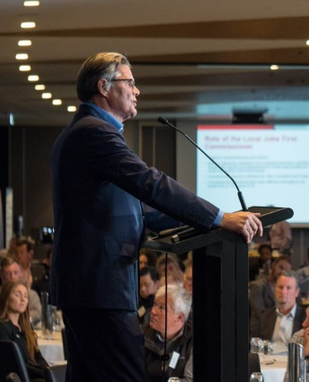
4 Don Matthews, Local Jobs First Commissioner

Local Jobs First in Regional Victoria 2018-19
6,213 jobs supported across Metropolitan Victoria
1,306 SMEs involved in projects across Metropolitan Victoria
Loddon Mallee
- 42 projects
- $216 million
- 891 jobs supported by projects
- 164 SMEs getting work
- 90% average local content
Grampians
- 37 projects
- $293 million
- 1,562 jobs supported by projects
- 299 SMEs getting work
- 87% average local content
Barwon South West
- 57 projects
- $207 million
- 1,423 jobs supported by projects
- 207 SMEs getting work
- 87% average local content
Hume
- 30 projects
- $152 million
- 848 jobs supported by projects
- 207 SMEs getting work
- 91% average local content
Gippsland
- 51 projects
- $177 million
- 735 jobs supported by projects
- 334 SMEs getting work
- 93% average local content
These figures above include both commenced and completed projects. Specific location information not provided for five Regional projects.
$846 million worth of projects commenced in Regional Victoria
$380 million worth of projects completed in Regional Victoria
81 projects completed in Regional Victoria
134 projects in commenced Regional Victoria
132 Standard Projects and 2 Strategic Projects commenced in 2018–19

Local Jobs First – outcomes in 2018–19

Local Content
All Local Jobs First projects require an LIDP that outlines the competitive local components and businesses that will be engaged, providing opportunities for local industry and workers. These local goods and services are referred to as local content.
Local is defined as businesses in Australia and New Zealand producing goods, providing services or construction activity, and when local content has been added to imported items through activities such as assembly or installation.
In 2018–19, 753 projects were registered with the ICN. A total of 2,239 LIDPs were prepared by businesses in bidding for projects. This represents a 37 per cent increase in the number of LIDPs reviewed by ICN over the same period last year.
The successful bidders for projects that commenced in 2018–19 have committed in LIDPs to using an average of 73 per cent local content.

Local Jobs First Standard Projects
Local Jobs First Standard Projects are all projects that meet the minimum value thresholds – $1 million or more for projects based in regional Victoria, and $3 million or more in metropolitan Melbourne or with statewide significance.
These projects require tenderers to complete an LIDP that outlines the expected local content to be achieved.
In 2018–19, 332 Standard Projects commenced worth a total of $2.4 billion, with 132 being delivered in regional Victoria. These projects will provide opportunities for 1,722 local SMEs and support 5,361 jobs.
A total of 220 Standard Projects, valued at over $1.8 billion, were completed in 2018–19, delivering more than 8,000 jobs, including 1,508 apprenticeships, traineeships and cadetships and providing opportunities for 704 local SMEs. Of these completed projects, 80 were in regional Victoria.

Local Jobs First Strategic Projects
Local Jobs First Strategic Projects are projects valued at $50 million or more or as determined by the Minister for Jobs, Innovation and Trade. These projects have minimum local content requirements and other conditions, such as requirements around the use of local steel products, set by the minister on a case-by-case basis to drive economic activity and job outcomes.
All bidders must complete an LIDP that details local content, jobs and other commitments, along with any other industry engagement activities, and demonstrate how these commitments will be met.
As at 30 June 2019, a total of 126 Local Jobs First Strategic Projects had commenced since November 2014, with a combined value of $65 billion. These projects are expected to deliver an average of 89 per cent local content, provide opportunities for local SMEs and support tens of thousands of jobs.
In 2018–19, the government set local content requirements for 33 Strategic Projects at a minimum average of 92 per cent, worth $8.1 billion collectively. This includes 10 projects in regional Victoria.
Table 1 sets out the Strategic Projects that have had local content commitments set during 2018–19 and projects that commenced in previous years where delivery is ongoing.
Table 1: Local Jobs First Strategic Projects – status at 30 June 2019
Project | Location | Minimum Local Jobs First requirements

Local Content Set In 2018-19
Alfred Hospital Urgent Infrastructure | Metropolitan Melbourne | 92% local content
Avon River Rail Bridge Project | Gippsland Region | 94% local content
Bendigo GovHub | Loddon Mallee Region | 90% local content
Bendigo Law Courts Development | Loddon Mallee Region | 92% local content
Bus Infrastructure Project - Design, Supply, Installation and Maintenance | State-wide | 95% local content - construction  95% local content - maintenance
Case Management System Project - Court Services | State-wide | 90% local content
Chisholm Road Prison Project | Barwon South-West Region | 92% local content  Maximise local steel
Fishermans Bend Secondary School | Metropolitan Melbourne | 91% local content
Geelong Convention and Exhibition Centre | Barwon South-West Region | 90% local content
Geelong Performing Arts Centre Stage 3 Redevelopment | Barwon South-West Region | 90% local content
Gippsland Regional Aquatic and Leisure Centre | Gippsland Region | 90% local content  Maximise local steel
Lockerbie Main Sewer | Metropolitan Melbourne | 97% local content
M80 Northern Sections (Plenty Rd to Edgars Rd) | Metropolitan Melbourne | 95% local content
Marvel Stadium Redevelopment | Metropolitan Melbourne | 90% local content
McKinnon Secondary College | Metropolitan Melbourne | 92% local content
Monash Freeway (M1) Upgrade - Stage 2 | Metropolitan Melbourne | 96% local content
Monash Medical Centre - Emergency Department and Traffic Improvement Project | Metropolitan Melbourne | 90% local content
New Schools 2020 Program | State-wide | 91% local content  Maximise local steel
New Schools 2021 Program | State-wide | 91% local content
North East Link Early Works | Metropolitan Melbourne | 93% local content
Northern Roads Upgrade Project | Metropolitan Melbourne | 96% local content - project  98% local content - maintenance
Safe System Infrastructure Program Towards Zero | State-wide | 95% local content - supply of wire rope safety barrier and W-beam guardrail systems  97% local content - installation and pavement works
Safe System Roads Infrastructure Program | State-wide | 90% local content
South East Water Reliability Program | Metropolitan Melbourne | 80% local content - project  70% local content - manufacture and supply of pipes
South Eastern Roads Upgrade Project | Metropolitan Melbourne | 96% local content - project  98% local content - maintenance
State Basketball Centre Redevelopment | Metropolitan Melbourne | 90% local content
State Netball and Hockey Centre Redevelopment | Metropolitan Melbourne | 91% local content  Maximise local steel
Technical Advisory Services - Major Road Projects Victoria | State-wide | 95% local content
Traralgon Indoor Sports and Entertainment Complex Upgrade | Gippsland Region | 91% local content  Maximise local steel
Upper Yarra Reservoir Safety Upgrade | Metropolitan Melbourne | 96% local content
Victorian Rail Infrastructure Program - Legal Services | State-wide | 98% local content
Warrnambool Line Upgrade | Barwon South-West Region | 93% local content - preconstruction and construction  68% local content - signalling
Wonthaggi Hospital Expansion | Gippsland Region | 90% local content
Strategic Projects – ongoing in 2018-19
Asbestos Removal Program | State-wide | 90% local content - permanent modular school buildings program  95% local content - asbestos removal and reinstatement program  Maximise local steel
Ballarat GovHub | Grampians Region | 91% local content  Maximise local steel
Ballarat Line Upgrade | Grampians Region | 92% local content - construction  65% local content - signalling  Maximise local steel
Boneo Water Recycling Plant Stage 4 Upgrade | Metropolitan Melbourne | 82% local content- design and construction  88% local content – operations and maintenance  Maximise local steel
Casey Hospital Expansion | Metropolitan Melbourne | 85% local content
Chandler Highway Upgrade | Metropolitan Melbourne | 92% local content
Chisholm Frankston TAFE Redevelopment - Stage 1 | Metropolitan Melbourne | 93% local content  Maximise local steel
CityLink-Tullamarine Freeway Widening – Bulla Road to Airport | Metropolitan Melbourne | 95% local content - construction  80% local content - signalling
Craigieburn Sewerage Transfer Hub | Metropolitan Melbourne | 80% local content
Dame Phyllis Frost Centre Expansion Project | Metropolitan Melbourne | 92% local content  Maximise local steel
Drysdale Bypass Project | Barwon South-West Region | 96% local content  Maximise local steel
Epping Main Sewer | Metropolitan Melbourne | 91% local content  Maximise local steel
Flinders Street Station Redevelopment – Heritage works (Phase 1 and 2) | Metropolitan Melbourne | 87% local content
Fulham Correctional Centre Expansion Project | Gippsland Region | 92% local content  Maximise local steel
Gippsland Hi-Tech Precinct | Gippsland Region | 91% local content  Maximise local steel
Goulburn Valley Health Redevelopment | Hume Region | 85% local content  Maximise local steel
Growth Areas School Project | State-wide | 91% local content  Maximise local steel
High Capacity Metro Trains - Train Maintenance Depot and Fleet | Metropolitan Melbourne | 87% local content - depot  50% local content - fleet
Joan Kirner Women’s and Children’s Hospital | Metropolitan Melbourne | 85% local content
Latrobe Creative Precinct | Gippsland Region | 90% local content  Maximise local steel
Level Crossing Removal Project - Melton Highway | Metropolitan Melbourne | 93% local content
Level Crossing Removal Project - North Eastern Program Alliance | Metropolitan Melbourne | 89% local content  100% local steel
Level Crossing Removal Project - North Western Program Alliance | Metropolitan Melbourne | 89% local content - construction  100% local steel
Level Crossing Removal Project - Package 3 - Caulfield to Dandenong | Metropolitan Melbourne | 92% local content - construction  50% local content - signaling  100% local steel
Level Crossing Removal Project - Package 5 - Thompsons Road Rail Grade Separation Project (Stage 1) | Metropolitan Melbourne | 92% local content  100% local steel
Level Crossing Removal Project - Southern Program Alliance | Metropolitan Melbourne | 93% local content - construction  100% local steel
Level Crossing Removal Project - Western Program Alliance | Metropolitan Melbourne | 93% local content - construction  100% local steel
M80 Ring Road Upgrade - Princes Freeway to Western Highway | Metropolitan Melbourne | 97% local content  Maximise local steel
M80 Ring Road Upgrade - Sunshine Avenue to Calder Freeway | Metropolitan Melbourne | 95% local content
Macalister Irrigation District 2030 Phase 1B - Southern Tinamba Modernisation Project | Gippsland Region | 70% local content – pipes  97% local content – installation  Maximise local steel
Maintenance of Freeway Integrated Transport System (ITS) Assets and Communications Network Project | Metropolitan Melbourne | 70% local content - communication network  96% local content - ITS assets  Maximise local steel
Melbourne Convention and Exhibition Centre Expansion | Metropolitan Melbourne | 60% local content
Melbourne Metro Tunnel Project - Core Package | Metropolitan Melbourne | 84% local content  Maximise local steel
Melbourne Metro Tunnel Project - Early Works | Metropolitan Melbourne | 88% local content
Melbourne Metro Tunnel Project - Independent Reviewer | Metropolitan Melbourne | 85% local content
Melbourne Metro Tunnel Project - Rail Infrastructure Alliance | Metropolitan Melbourne | 96% local content  Maximise local steel
Melbourne Metro Tunnel Project - Rail Systems Alliance - Control Systems & Signalling | Metropolitan Melbourne | 65% local content
Melbourne Metropolitan Train Network Project (MR4) | Metropolitan Melbourne | 84% local content  Maximise local steel
Melbourne Metropolitan Tram Network Project (MR4) | Metropolitan Melbourne | 83% local content  Maximise local steel
Melbourne Park Redevelopment - Stage 3 | Metropolitan Melbourne | 90% local content
Melbourne Park Redevelopment Stage 2 – Rod Laver Arena Refurbishment | Metropolitan Melbourne | 82% local content
Melbourne Underground Rail Loop Fire and Life Safety Upgrade - Stage 2 | Metropolitan Melbourne | 70% local content  Maximise local steel
Metropolitan Bus Project | Metropolitan Melbourne | 60% local content - bus assets  86% local content - bus operations
Metropolitan Road Assets Maintenance Services | Metropolitan Melbourne | 98% local content  Maximise local steel
Mordialloc Freeway | Metropolitan Melbourne | 96% local content  Maximise local steel
Murray River Crossing Echuca-Moama Bridge | Loddon Mallee Region | 94% local content - Murray Valley Highway/Warren Street roundabout  92% local content - Warren Street upgrade  93% local content - main bridge crossing  Maximise local steel
New Schools Public Private Partnership | State-wide | 90% local content
New Victoria Police Centre | Metropolitan Melbourne | 82% local content
New Youth Justice Centre - Cherry Creek | Metropolitan Melbourne | 90% local content  Maximise local steel
Northern Hospital Stage 2 - Inpatient Expansion Project | Metropolitan Melbourne | 90% local content  Maximise local steel
O'Herns Road-Hume Freeway Interchange Project | Metropolitan Melbourne | 96% local content  Maximise local steel
Orygen Youth Health Development | Metropolitan Melbourne | 90% local content  Maximise local steel
Parkville and Malmsbury Youth Justice Expansion Project | Metropolitan Melbourne | 92% local content  Maximise local steel
Penguin Parade Visitor Centre Redevelopment | Gippsland Region | 89% local content  Maximise local steel
Personal Alert Victoria | State-wide | 85% local content
Plenty Road Upgrade - Stage 2 (South Morang) | Metropolitan Melbourne | 97% local content  Maximise local steel
Police Assistance Line and Online Reporting | State-wide | 98% local content
Police Aviation Capability Program | State-wide | 85% local content
Princes Highway East Duplication - Stage 2 - Traralgon to Sale (Nambrok Stage) | Gippsland Region | 95% local content
Princes Highway East Duplication – Stage 3 – Traralgon to Sale | Gippsland Region | 91% local content
Princes Highway West Duplication - Section 2 - Armytage to Warncoort | Barwon South-West Region | 95% local content
Princes Highway West Duplication - Section 3 - Warncoort to Colac East | Barwon South-West Region | 96% local content  Maximise local steel
Public Housing Renewal Program Stage 1 | Metropolitan Melbourne | 91% local content  Maximise local steel
Route 96 Accessible Tram Stop Upgrade | Metropolitan Melbourne | 91% local content  Maximise local steel
Safe System Road Infrastructure Program - Pedestrian and Bicyclist | State-wide | 95% local content  Maximise local steel
Safe System Road Infrastructure Program - Road Departure Barriers | State-wide | 95% wire rope barrier and w-beam guardrail system  97% pre and installation works
Shepparton Law Courts Redevelopment | Hume Region | 85% local content
South-West Loddon Rural Pipeline Project | Loddon Mallee Region | 88% local content - Stage 1  87% local content - Stage 2  86% local content - Stage 3  Maximise local steel
State Library of Victoria Redevelopment | Metropolitan Melbourne | 80% local content
Streamlining Hoddle Street | Metropolitan Melbourne | 95% local content  Maximise local steel
Thompsons Road, Cranbourne Road Duplication Project - Stage 2 | Metropolitan Melbourne | 91% local content
Ticketing Services Retender | Metropolitan Melbourne | 70% local content
Victorian Heart Hospital | Metropolitan Melbourne | 99% local content – design services  98% local content - engineering services  90% local content – construction  Maximise local steel
Victorian Rail Infrastructure Program Technical and Financial Advisory Services | State-wide | 96% local content - technical services  98% local content - commercial and financial advisory services
Victorian Renewable Energy Auction | State-wide | 64% local content – projects  90% local content - operations phase  90% local steel
VLocity 2018 Trains | Metropolitan Melbourne | 65% local content
West Gate Tunnel Project | Metropolitan Melbourne | 89% local content - project  82% local content - lane use management system  Maximise local steel
Western Highway Duplication - Section 2B - Buangor to Ararat | Grampians Region | 95% local content
Western Suburbs Road Package - Construction and Roads Infrastructure Independent Reviewer | Metropolitan Melbourne | 92% local content - construction  93% local content - maintenance  96% local content - independent reviewer
Western Treatment Plant - Treatment Capacity Upgrade (Stage 2 Augmentation Project) | Metropolitan Melbourne | 80% local content
Western Water Engineering Services | Metropolitan Melbourne | 92% local content
X'Trapolis 2018 Metropolitan Trains | Grampians Region | 43.6% local content
Yan Yean Road Upgrade Project | Metropolitan Melbourne | 95% local content  Maximise local steel

Local Jobs First Strategic Projects – completed
During 2018–19, three Local Jobs First Strategic Projects were completed worth a total value of $610 million. These projects delivered an average of 94 per cent local content, provided opportunities for 42 local SMEs, supported 890 local jobs and 157 apprenticeships, traineeships and cadetships.
This brings the total to 13 Local Jobs First Strategic Project completed since November 2014, worth a combined value of $2.8 billion. These 13 projects have delivered a local content average of 94.4 per cent, supporting 4,606 jobs and 411 apprenticeships, traineeships and cadetships.
Table 2 sets out all the Local Jobs First Strategic Projects that have been completed along with the local content commitments and achievements since November 2014.
Table 2: All completed Local Jobs First Strategic Projects since November 2014, as at 30 June 2019
Project | Region | Year completed | Local Jobs First commitments | Local Jobs First achievements
Level Crossing Removal Project – Package 1 # | Metropolitan Melbourne | 2016-17 | 93.9% local content  100% local steel | 95.8% local content  100% local steel
Level Crossing Removal Project – Package 2 | Metropolitan Melbourne | 2016-17 | 94.7% local content  100% local steel | 95.7% local content  100% local steel
Level Crossing Removal Project – Package 4 | Metropolitan Melbourne | 2016-17 | 94.8% local content  100% local steel | 97.3% local content  100% local steel
Bendigo Hospital # | Loddon Mallee Region | 2017-18 | 90% local content | 90% local content
Calder Highway (Ravenswood) Interchange* | Loddon Mallee Region | 2017-18 | 95.1% local content | 97.5% local content
Latrobe Regional Hospital | Gippsland Region | 2017-18 | 85% local content | 85.4% local content
Monash Freeway Upgrade Stage 1 | Metropolitan Melbourne | 2017-18 | 95% local content – construction  88% local content - lane use management system | 96.5% local content – construction  89.9% local content - lane use management system
Princes Highway West Duplication- Winchelsea to Armytage (Section 1) | Barwon South West Region | 2017-18 | 97.3% local content | 100% local content
West Gate Distributor - Northern Section Stage 1 | Metropolitan Melbourne | 2017-18 | 94.6% local content  100% local steel | 95.5% local content  100% local steel
Werribee Mercy Hospital Stage 1C | Metropolitan Melbourne | 2017-18 | 85% local content | 87.9% local content
Mernda Rail Extension Project | Metropolitan Melbourne | 2018-19 | 92% local content | 97% local content
Provision of Managed Services to HealthSMART | State-wide | 2018-19 | 85% local content | 85% local content
Safe System Road Infrastructure Program | State-wide | 2018-19 | 90% local content | 99% local content
# Commenced prior to November 2014
* Project requirements set and project completed in 2018-19

Local Jobs First – Major Projects Skills Guarantee
Since its introduction in 2016, the MPSG has been applied to 116 projects worth collectively more than $63.6 billion, which have committed to more than 4 million contracted hours for 3,700 apprenticeships, traineeships and cadetships. This includes 24 regional projects that have committed more than 250,000 hours to 145 apprenticeships, traineeships and cadetships.

Grants
Victorian Government grants that meet the monetary thresholds are also required to apply Local Jobs First to ensure that procurement activities consider local businesses.
Recipients of grants must engage with the ICN to discuss opportunities for local SME inclusion on the grant activity. An Interaction Reference Number confirming engagement is issued by the ICN and must be submitted by the grant recipient to the funding government department or agency to demonstrate that local businesses were considered.
During 2018–19, a total of 46 grants were registered with the ICN.

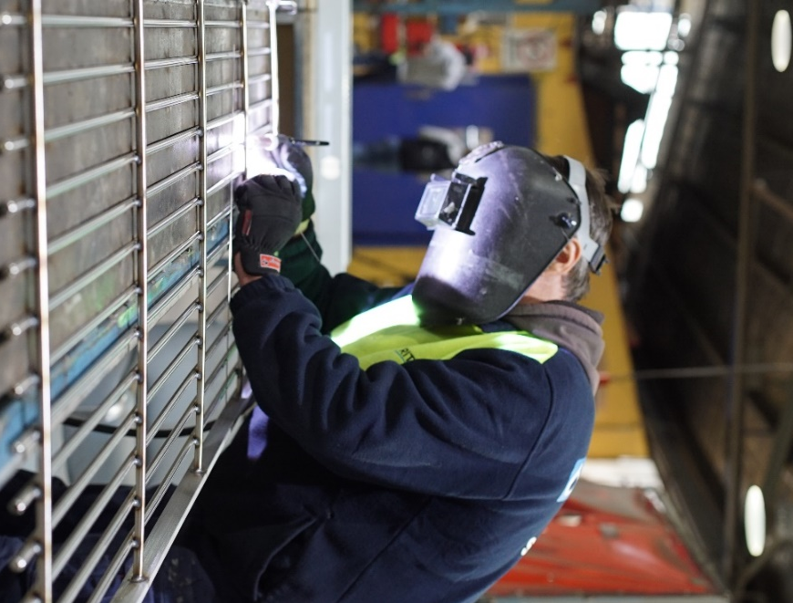
5 Image of metal worker welding steel grate
Britex is a Victorian manufacturer that was part of the supply chain for the Victorian New Schools PPP Local Jobs First Strategic Project. Britex manufactured and installed various custom fabricated stainless-steel fixtures such as water fountains, laboratory sinks and toilets.
The schools that benefited from these locally manufactured products include Point Cook South Prep-Year 9, Epping North Primary School, Pakenham South West Primary School and Heather Grove Primary School.
(Photo credit: Brave)

Local Jobs First in Statewide 2018-19
$707 million of statewide projects that were completed in 2018-19
$1.5 billion of statewide projects that commenced in 2018-19
1,572 jobs supported by statewide projects
119 SMEs getting work thanks to statewide projects
59% is the average local content for statewide projects
100 projects that were statewide (projects that were completed or commenced in 2018-19)
33 Statewide Standard Projects and 1 Statewide Strategic Project were completed in 2018-19
60 Statewide Standard Projects and 6 Statewide Strategic Projects commenced in 2018-19

Local Jobs First - Compliance

Engagement and awareness
The commencement of the new Act in August 2018 has enabled a stronger Local Jobs First compliance framework. The Local Jobs First Commissioner has been actively ensuring compliance with Local Jobs First, engaging government departments and agencies, and local businesses to ensure agreed commitments are met.
Throughout 2018–19, DJPR and the Local Jobs First Commissioner increased awareness of Local Jobs First through organising seven Local Jobs First forums for suppliers and agencies and presenting at other organisation’s events around Victoria on a regular basis.
With the significant increase in the number and type of Local Jobs First applicable projects, the ICN has reported a large increase in engagement activities with local SMEs, departments and agencies on the implementation of Local Jobs First, including project assessments and LIDP acknowledgements.
ICN also delivered eight project related briefing sessions and hosted three regional showcases during 2018–19, connecting more Victorian businesses to government project opportunities. Events were held in metropolitan Melbourne and regional cities such as Shepparton, Bendigo and across Gippsland.

Compliance reporting
There was improvement in reported compliance by departments and agencies compared to 2017–18.
Overall, agencies reported three non-compliant projects or grants in 2018–19, compared to six in 2017–18, 26 in 2016–17, 28 in 2015–16 and 125 in 2014–15.
Thirty project audits will be undertaken by DJPR in 2019–20, helping to inform future improvements of Local Jobs First.
The Act provides the Local Jobs First Commissioner with specific compliance functions. A robust and transparent compliance framework was established in 2018–19.
The Local Jobs First Commissioner did not make any recommendations to the Minister for Jobs, Innovation and Trade to issue any Adverse Publicity Notices in accordance with section 29 of the Act during 2018–19.
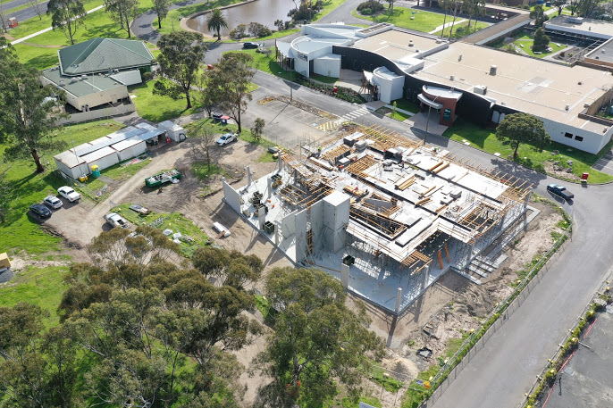
6 Gippsland Hi-Tech Precinct site
The Gippsland Hi-Tech Precinct will be a centre for research, business incubation, new product development, start-up support, plus education and training.
The new Innovation Centre will incorporate creative and innovative spaces to promote design thinking and practice. It will support the growth of local industry and play an important role in supporting the expansion of the region’s growth sectors – health, food and fibre, advanced manufacturing and new energy.
(Photo credit: Latrobe Valley Authority)

DISCLAIMER
This publication may be of assistance to you, but the State of Victoria and its employees do not guarantee that the publication is without flaw of any kind or is wholly appropriate for your particular purposes and therefore disclaims all liability for any error, loss or other consequence which may arise from you relying on any information in this publication.
While every effort has been made to ensure the currency, accuracy or completeness of the content we endeavour to keep the content relevant and up to date and reserve the right to make changes as require. The Victorian Government, authors and presenters do not accept any liability to any person for the information (or the use of the information) which is provided or referred to in the report.
Authorised by the Victorian Government
Department of Jobs, Precincts and Regions
121 Exhibition St, Melbourne Victoria 3000
Telephone: 13 22 15
Prepared under section 10
of the Local Jobs First Act 2003
November 2019
© State of Victoria 2019
Unless indicated otherwise, this work is made available under the terms of the Creative Commons Attribution 3.0 Australia Licence. To view a copy of this licence, visit creativecommons.org/licenses/by/3.0/au.
It is a condition of this Creative Commons Attribution 3.0 Licence that you must give credit to the original author who is the State of Victoria.
This document is available in PDF and accessible Word format at localjobsfirst.vic.gov.au

Project value greater than $50 million
Projects that commenced or were completed in the 2018–19 financial year
Projects that commenced or were completed in the 2018–19 financial year

